 | Literacy Links
October, 2009  Volume 6, Number 3 | Monthly E-Newsletter of Maine Reading First
“Focusing vocabulary instruction on acquiring root words is an effective way to address the large number of words that students must learn each year.”  --Biemiller & Slonim (2001) | The previous editions of literacy Links dealt with Vocabulary Development and Vocabulary Instruction. This issue will extend that understanding and focus on a specific aspect of vocabulary: morphology.  Spotlight on…  Morphology  When does phonics instruction merge with vocabulary instruction? When learning to read and write, students’ progress through the hierarchy of phonics skills that build strong foundations for decoding  and constructing understanding of connected text. As students become more sophisticated readers, they need more advanced decoding and encoding strategies that focus on word structure (i.e. roots, prefixes, and suffixes). This knowledge provides students a strategy for segmenting multi-syllabic words into decodable parts for determining the meaning of the word (Henry, 1997). Additionally, most students do not discover the powerful relationships between spelling and vocabulary on their own (Bear, et al 1996). Therefore, direct instruction in word structure (morphology) provides another powerful instructional tool for building vocabulary.  Why is it important to study morphology?  Teaching and learning key morphological principles will expand students’ understanding and usage of vocabulary exponentially. Here is why: 90 percent of English words with more than one syllable are Latin based and the remaining 10 percent are Greek based. Knowing a single root can help us understand 5-20 related English words. It is clear that knowing how to unlock the meaning of new words is an important lifelong skill (growth construct). “Understanding how words work shows us how to think about words in new ways, and how to connect this deeper understanding to what we already know. Only those students who have mastered the conceptual vocabulary at a lower level are well equipped to unlock the meanings of academic

words in later learning, particularly in content areas” (Rasinski et al. 2008).

What does morphology instruction look like?

Upcoming Maine Reading First
Events

The Maine Reading First Literacy Leaders’ Network (LLN) for the 2009-10 school year is underway! To learn more about the LLN, visit: http://www.maine.gov/e ducation/rf/.materials.h tml or contact: Leeann.Larsen@maine. gov
Begin with the Root:
“Latin and Greek prefixes, roots and suffixes are fairly consistent in their meaning and spelling patterns. Consequently, students can figure out the pronunciation and meaning of many new words by looking at the roots of the word” (Rasinski, et al, 2008). Rasinski, et al, go on to make this analogy for word learning: “Words, like stories, have a structure….In order to understand a story, we often take it apart so we can think and talk about all the things that occur in the beginning, middle, and end of the plot. Likewise, many English words-- and nearly all academic words our student must learn---are made up of parts. Like the parts of a story, the parts of a word carry meaning. And that is precisely what a word root (morpheme) is: a part of a word that carries meaning” (2008, p 25-26). They continue explaining by asking us to think about this: “…a word is composed of letters; but letters by themselves, carry only sound, not meaning.
Similarly, the phonemes that students learn to recognize in primary grades are associated with letter or letter combinations that produce sounds, but not meaning. In other words, a correctly decoded or pronounced word is understandable only when a student already knows what it means. Thus, a full knowledge of letters and phonemes does not generate growth in vocabulary or word comprehension” (2008, 26).
Now, compare a phoneme with a word root (morpheme): “…simply, (morphemes are) word parts that mean something. Unlike the phoneme, the root conveys not only sound but also meaning” (Rasinski, et al, 2008, p.27).
By using a “roots approach to vocabulary learning, students discover how to look for meaningful connections between words they already know (like motor) and words they may not know (like motif), as well as with words they may have heard before but only vaguely know (like demotion or motivate). This discovery may also bring them to a deeper understanding of a familiar word. When we teach vocabulary based on root words rather than word lists, we encourage students to search for a word’s meaning from the meaning of its root” (Rasinski et al, 2008 p.28-29). By associating these words with their cognates (from Latin cognatus, which means “born together, related in origin”), students learn that words that contain the same root also share meaning. “For example, a common English root is mot. The root, mot,

The Maine Department of Education’s Reading First initiative is conducting a series of regional Free professional development opportunities in literacy for every Maine elementary school
during October and November 2009.
Every Maine elementary school will receive a set of training videos in DVD format, a copy of the study guide, and professional development related to ways in which these resources can be used in their schools. All schools can send two educators to one location; the web-link for registration for this is: http://www.surveymonke y.com/s.aspx?sm=bwqP UutDYZXXiyyf_2f_2f3 G5Q_3d_3d
is not a word in itself, but it is more than a phoneme because mot means something. Mot means move. Think about “mot” words: motor, motorcycle, locomotive, motion, commotion, promoted, remote control. Words with a shared root have a shared meaning; they are cognates” (Rasinski et al, 2008, p.27).
One simple instructional routine suggested by Rasinski et al is “By drawing a box around or highlighting the root that all these words share (mot), you can give your students a “root awakening!!” (2008, p. 28).

Include Prefixes and Suffixes:
Simply teaching root words will not be sufficient. Students will, of course, need to understand how all word parts are interrelated and how these parts carry meaning in context.
Rasinski, et al (2008), propose a “Divide and Conquer” strategy for primary level students: teach basic roots, and then get students “into words”. They suggest a somewhat “developmental approach by beginning with compound words, progressing to negative prefixes (e.g., un- and in-), adding directional prefixes (e.g. pre- and re-) and moving on to easy suffixes (e.g. –er,-est,-ful,-less,-able,-ible)” (p.64-65).
Another way we might think about this is as a hierarchy of morphological skills. When we are “helping students learn to focus on prefixes and suffixes, they will notice that prefixes and suffixes are always attached to something else in the word” (Rasinski, 2008, p. 64)
-- that is the root or base word. “It provides the word its ‘basic’ meaning; by themselves the prefix and suffix affect meaning but cannot generate a word” (p. 64). Thankfully, in English, the meanings of roots/base words that are “derived from Latin and Greek are usually simple and straightforward (e.g. audi, audit=”hear, listen”; vid, vis = “see”)” (Rasinski et al, 2008, p. 65).

So What, Now What?
So far we have discussed instruction that focuses on word recognition and word parts. This helps students develop control over their “passive vocabularies” (the words they encounter when reading). We must also help students build “active vocabularies”---learn to produce a word to fit the context for composition—generate vocabulary that communicates a message (e.g. what they want to say, tell, retell or relay). To build “active vocabularies” with primary students, it is suggested teachers use riddles and metaphors to link morphological learning to vocabulary usage. Current vocabulary research also supports getting students using their school vocabulary

Attention Attention...

Early Language and Literacy Professional Development Training Series Sponsored by MELLI and facilitated by Jean Sullivan;
This six part series is educators opportunity to learn current research support practices in literacy development from Birth to age 5.
Contact Becky Dyer at becky@mainefamily ylitercy.com or
in everyday conversation.
Rasinski, et al (p. 70-71) suggest four sound reasons why effective vocabulary instruction should focus on the literal and configurative meanings of word roots:

- We remove the fear factor from vocabulary.
- Students learn that by talking about a word in terms of its root, they often have background knowledge they can activate.
- As students focus on roots they recognize inside new words, they recall words they already know but never thought about as cognates.
- The “roots approach” to vocabulary instruction mirrors the process which users of language arrive at--an understanding of new ideas and concepts.

"Morphological knowledge is a wonderful example of the child uncovering ‘what's in a word’, and one of the least exploited aids to fluent comprehension" (Wolf, 2007, p. 130).

References:

Rasinski, T., N. Padak, R.M. Newton, and E. Newton (2008) Greek & Latin Roots: Keys to Building Vocabulary. CA: Shell Education.

Moats, Louisa (2000). Speech to Print: Language essentials for Teachers. Baltimore: Brookes Publishing.

Ebbers, Susan (2009) Blog 2 at http://vocablog-plc.blogspot.com

207-441-9965 for
registration details

and information.

Instructional Tools…..

Chart of Prefixes and Suffixes for Teaching Multi-Syllabic Words
This chart by Ruth Gumm (NFConfernece, 2009) is offered as a tool for teachers when teaching morphological elements.

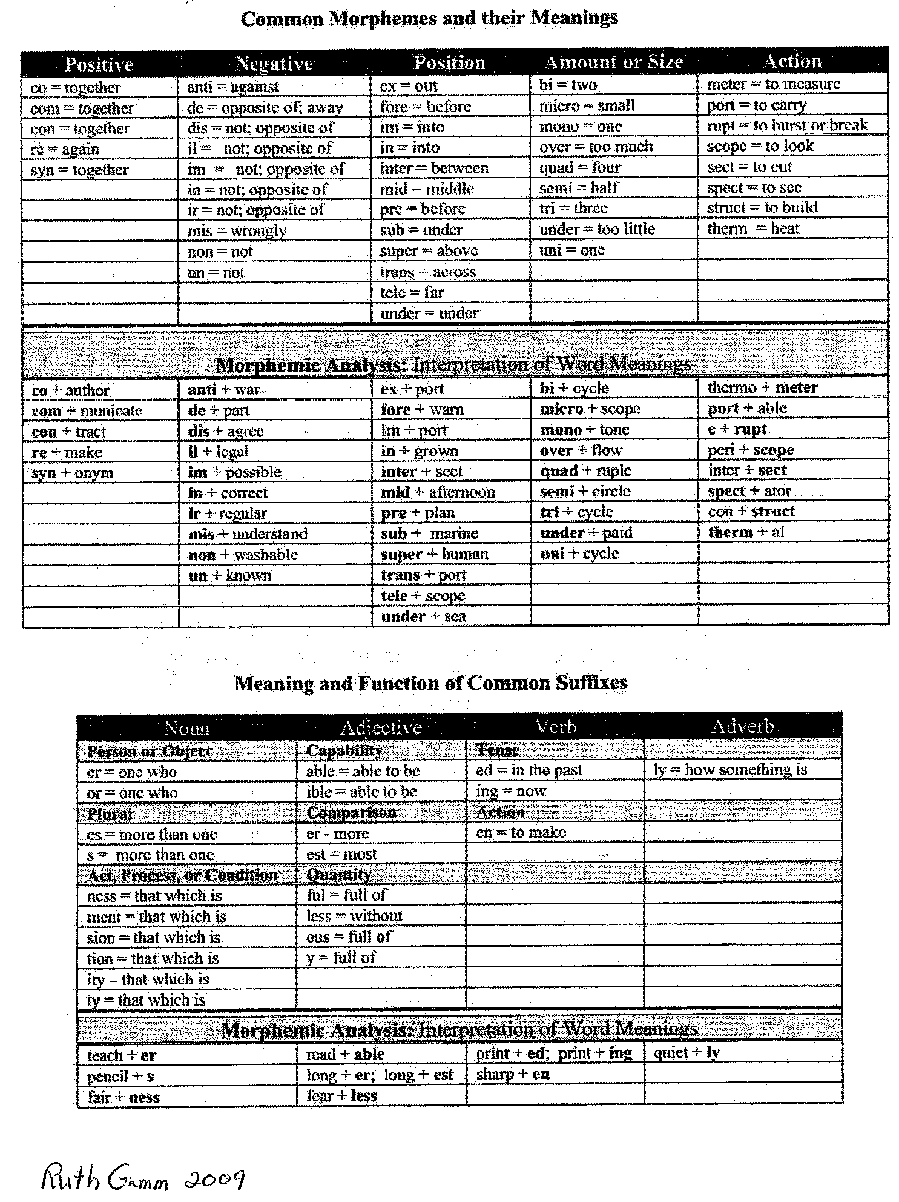

UPCOMING EVENTS

USM 2009-10
RTI Workshop Series

Sponsored by the University of Southern Maine’s Professional Development Center

Sessions begin September 25, 2009 and continue through June 4 2010

More information is available through www.usm.maine.edu/pdc

Online Instructional Resources:
Susan Ebbers in her blog (http://vocabularyblog-plc.blogspot.com) suggests additional links for word work:

Fact Monster

http://www.factmonster.com/

Sponsored by Pearson Education 2000-2009, this site has many resource sections for students and ideas for teachers and parents including: a reference desk, content area topics, and special feature topics, as well as an almanac, dictionary, encyclopedia, and thesaurus.

The Free Dictionary

http://www.thefreedictionary.com

This free on-line dictionary site is privately owned by Farlex, Inc 2009. In addition to the dictionary, the site includes a word of the day feature, daily word games and activities, a feature article, and other specialty sections.

Word Spy

Attitude is a little thing that makes a

The Word Lover’s Guide to New Words

http://www.wordspy.com/

At this site, the reader is able to search newly created words and sources where these “invented” words have recently been used. This site is created by Paul McFedries and Logophilia Limited.

big

difference.

--Winston Churchill

Description of Instructional Ideas…

Vocabulary Instructional Routine

Determine the Meaning of a Word Using Knowledge of Base Words and Affixes
This instructional routine is from the Florida Center for Reading Research. It requires students to have knowledge of two previously taught instructional routines: Identify Base Words and Suffixes to Read Multi- Syllabic Words #1 and #2. Like the other routines found on this site, the teacher explains and models the task. Then, the teacher and students practice the task together. Finally, the students practice the task independently. After teaching the routine, guidance for independent student practice and scaffolding suggestions are given.
For explicit instructions on how to use this instructional routine and others, click on the live link below: http://fcrr.org/assessment/et/routines/pdf/instRoutines_3VBWA.pdf

Summary of Professional Texts…

Greek and Latin Roots:
Keys to Building Vocabulary

by Timothy Rasinski, Nancy Padak, Rick M. Newton and Evangeline Newton

A pessimist sees the difficulty in every opportunity; an optimist sees the opportunity in every difficulty.

--Winston Churchill
“The information in Greek and Latin Roots: Keys to Building Vocabulary (2008) is critical to being a good vocabulary teacher at all grade levels. It is a terrific book that can help classroom teachers, content-area teachers, reading specialists, staff developers, and curriculum coordinators, as they support students in learning how to “divide and conquer” multi-syllabic words. First, it provides a synopsis of the theory and research that supports teaching multi- syllabic words by dissecting roots (prefixes, bases, and suffixes). Second, the book offers ideas for planning vocabulary instruction, including activities to engage students in actively understanding roots as they become independent word learners. Third, the book includes valuable resources such as extended lists of commonly taught roots and their meanings, professional resources for teachers, websites, dictionaries, and sources for lesson plans. This book is a good choice for a teacher’s study group (from the forward by Karen Bromley, 2008).”
Greek and Latin Roots: Keys to Building Vocabulary (2008) by Timothy Rasinski, Nancy Padak, Rick M. Newton and Evangeline Newton is available from Shell Education and the ISBN-13: 978-1-4258-0472-5.

Teaching Vocabulary in All Classrooms, (NEW) 4th Edition

By Camille Blachowicz and P.J. Fisher
Each chapter in Teaching Vocabulary in all Classrooms (2009) is full of classroom-tested strategies. Topics include content-area vocabulary, integrating reading and writing, learning from context, using reference sources, word play and assessment. Literacy experts Camille Blachowicz and Peter Fisher wrote this book for teachers who have a sense of direction but who want some new, classroom-tested strategies to renew their curriculum. This new edition includes a wealth of new material. It expands its treatment of independent, metacognitive strategies for learning vocabulary, such as using contextual cues and references.
Teaching Vocabulary in All Classrooms (2009) by Blachowicz and Fisher will be available from Allyn and Bacon on March 6, 2009 and the ISBN-13 is 978-0135001899.

Children’s Literature…
ANU GARG, the founder of Wordsmith.org, is also the creator of the A.Word.A.Day e-mail newsletter with more than 600,000 subscribers. Garg is the author of the books:

Good judgment comes from experience, and often experience comes from bad judgment.

--Rita Mae Brown
A Word A Day: A Romp Through Some of the Most Unusual and Intriguing Words in English (2002), available from Willey and Sons: IBSN 13 is 978-0471230328; and Another Word A Day: An All-New Romp through Some of the Most Unusual and Intriguing Words in English (2005) is published by Wiley ad Sons and the ISBN 13 is 978- 0471718451.
In Anu Garg’s most recent book, The Dord, the Diglot, and an Avocado or Two: The Hidden Lives and Strange Origins of Common and Not-So-Common Words, he once again provides us with a collection of some of the most interesting stories and fascinating origins behind more than 300 words, names, and terms. This book, published in 2007, is available from Plume Publishers and the ISBN-13: 978-0452288614.

Home Connections…

Word Building Ideas for Parents
For many years, word games and word play have been a common activity to engage children during periods of inactivity; such as long car rides or waits in the doctor’s office. With the upcoming holiday season and the possibility of many of families traveling or hosting a house full of relatives, think about including suggestions for “word play” games in your local school newsletter for parents to use as a way to keep kids entertained.

Some simple games for long rides:

Automatic Alphabet
The object of this game is to name a word for each letter of the alphabet in alphabetical order. This can be played with individuals, in partners, or as a group. You can also add a time element if you want to make it more exciting. On long car rides, the goal might be to look for objects along the roadside in the order of the alphabet (e.g. A- apple tree, B baseball field, C-Carport, etc).

Sign Synonyms
In this game, you try to say a synonym for every road sign you see. For example: STOP-“halt, cease, desist”. You can extend the word play to multiple meanings for STOP, such as “conclude, finish, stay, end, discontinue, block, forbid”. Another example is: YIELD— “concede, give way” with multiple meanings such as “relent, soften,

give, create”. See who can come up with the most synonyms. Then use the multiple meanings to “picture” our world if the sign said “forbid” or “block”?

Some at home “Word Play”:
Either of the games above could be played at home using objects easily seen around the house. Another fun word game is:

He who can take advice is sometimes superior to those who give it.
--Old Chinese Proverb
“I Spy”
“I spy with my little eye something that begins with the letter:
.” The first to guess the correct object takes the next turn.

Additionally, you might send home the web-links to a variety of Student/Parent friendly websites for families to “play with”. A good site to begin with is:
http://wordsmith.org .
On this site, families can access the Word A Day feature and make it a part of their daily routines as a computer “play” activity.

Some other familiar word games to suggest are the old standbys such as “Boggle”, “Scrabble” and “Hangman”. These make great holiday gifts.

News from Maine Reading First…
We want your suggestions! As you peruse the monthly editions of Literacy Links, you might have topic ideas for the spotlight, instructional strategy, children’s literature, professional text, or web site resource sections. We’d love to hear your suggestions. Please email them to: geecon@fairpoint.net.

Check it out…

One Look Dictionary Search
http://onelook.com
This is an online dictionary that allows the learner to search by word or phrase, definition, find translations and browse other dictionaries. Advanced help is provided through wildcard and reverse dictionary searches: related concepts, category, clarifying questions and crossword puzzle clues. This site can be used to generate root word lists/word families.

Newsletter Archives
Earlier editions of Literacy Links available on the Maine Reading First website at http://www.maine.gov/education/rf/homepage.htm

SNEAK PREVIEW

IN 2010 Literacy Links—

- Instructional Routines

- Oral Language

- Strategies for non-fiction comprehension
Edition Spotlight Topic
March, 2005 Maine Reading First
April, 2005 Maine Reading First Course
May, 2005 Reading Fluency
June, 2005 Vocabulary
September, 2005 Phonemic Awareness
October, 2005 Phonics
November, 2005 Comprehension December, 2005/January,2006 DIBELS February, 2006 Literacy Centers
March, 2006 Interactive Read Aloud
April, 2006 Nonfiction
May, 2006 Word Walls
June, 2006 Classroom Design
September, 2006 Shared Reading
October, 2006 Automaticity
November, 2006 Using Assessment to Guide Instruction
December, 2006 Deepening Comprehension
January, 2007 Selecting Quality Children’s Books (part 1)
February, 2007 Selecting Quality Children’s Books (part 2)
March, 2007 Making Instruction Explicit
April, 2007 Motivation and Engagement
May-June 2007 Grouping for Instruction
September 2007 Making Instruction Systematic
October, 2007 Pacing Instruction
November, 2007 Managed Independent Practice
December, 2007 A Deeper Look at Phonemic Awareness
January, 2008 Phonics at the K-2 Grade Span
February, 2008 Phonics and Word Work Grades 3-5
March, 2008 Vocabulary Revisited
April, 2008 A Deeper Look at Vocabulary Instruction
May-June 2008 Fluency Revisited
August 2008 Fluency Assessment
September-October 2008 The Revised Maine Learning Results English Language Arts Standards
November 2008 Comprehending Comprehension
December 2008 Comprehension Strategies
January 2009 Response to Intervention (RTI)
February 2009 Multiple Tiers of Intervention
March 2009 Universal Screening and Progress Monitoring for RTI

 |  | April 2009 | Collaborative Problem-Solving for RTI
 |  | May-June 2009 | Purposeful Text Selection
 |  | August 2009 | Vocabulary Development
 |  | September 2009 | Vocabulary Instruction
For additional information about any of the items in this newsletter or to sign up to receive this e-newsletter, please email Leeann.Larsen@maine.gov

Click here to view the Maine Reading First website http://www.maine.gov/education/rf/homepage.htm
The professional development opportunities and materials are listed in Literacy Links for informational purposes only and are not necessarily endorsed by the
Maine Department of Education’s Maine Reading First Initiative.

